WEEK 3

1.
import java.util.Scanner;
class original {
void count() {
Scanner sc = new Scanner(System.in);
int a = sc.nextInt();
int[] arr = new int[a];
for (int i = 0; i < a; i++) {
arr[i] = sc.nextInt();
}
int o = sc.nextInt();
int temp,flag=0,res;
for (int i = 0; i < a; i++) {
for (int j = i + 1; j < a; j++) {
if (arr[i] > arr[j]) {
temp = arr[i];
arr[i] = arr[j];
arr[j] = temp;
}
}
}
for (int k = 0; k < a; k++) {
if (o == arr[k]) {
res = o * 2;
o=res;
flag=1;
}
}
if(flag==1)
System.out.println(o);
else
System.out.println(-1);

}
}

public class zero extends original {
public static void main(String[] args) {
original ori = new original();
ori.count();
}
}
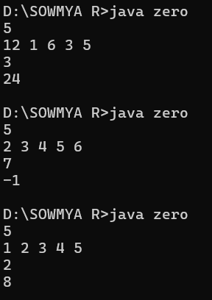

2.
import java.util.Scanner;
class pro
{
void gain()
{
Scanner s = new Scanner(System.in);
int n = s.nextInt();
int arr[] = new int[n];
for (int i = 0; i < n; i++)
{
arr[i] = s.nextInt();
}
int minPrice = arr[0];
int maxProfit = 0;
for (int i = 1; i < n; i++)
{
if (arr[i] < minPrice)
{
minPrice = arr[i];
}
else if (arr[i] - minPrice > maxProfit)
{
maxProfit = arr[i] - minPrice;
}
}
System.out.print(maxProfit);
}
}
public class profit extends pro
{
public static void main(String args[])
{
pro p = new pro();
p.gain();
}
}
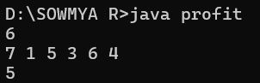
3.
import java.util.*;
class array
{
void sorting()
{
Scanner sc = new Scanner(System.in);
int n = sc.nextInt();
int arr[] =new int[n];
int temp;
for(int i=0;i<n;i++)
{
arr[i]=sc.nextInt();

}
for(int i=0;i<n;i++)
{
for(int j=i+1;j<n;j++)
{
if(arr[i]>arr[j])
{
temp=arr[i];
arr[i]=arr[j];
arr[j]=temp;
}
}
}
for(int i=0;i<n;i++)
{
System.out.print(arr[i]+" ");
}
}
}
public class sort extends array
{
public static void main(String[] args)
{
array ss = new array();
ss.sorting();
}
}
